Out of Band communication between gRPC and Main loops
Data can be sent between the gRPC loop and the Main loop for monitoring and control. There are two built-in mechanisms that can be used.

Cyclic data:
There are two clusters in the class data that can be used passing data. These values are automatically updated each loop iteration.
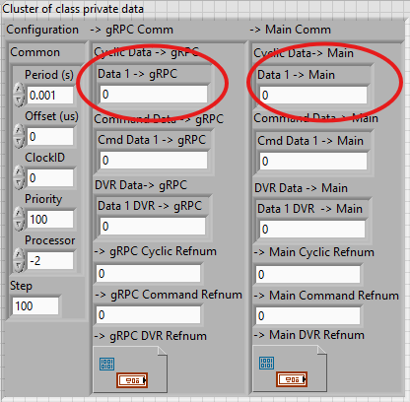
The ->gRPC passes data from main to gRPC. It should be written from the main loop only.
The ->Main passes data from gRPC to main. It should be written from the gRPC loop only.
The cyclic data can only contain fixed size elements. It cannot contain strings or arrays.

Commands:
Commands can be sent in a queue between gRPC and main loops. The command will pass both a command enum and command data. The built-in commands in the enum are “Read Data” and “Read DVR”. The Data and DVR fields are both exposed as clusters in the Class data.
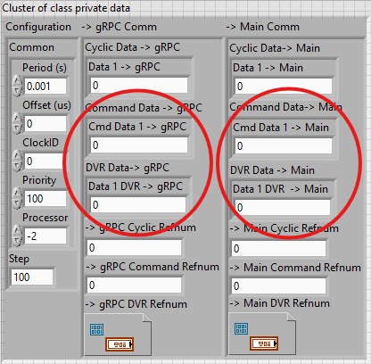
Command Data must be fixed size. The DVR can contain any data. The DVR can cause more jitter in the main loop so Command Data mechanism is preferred when possible.
To use commands a command function must be created and then called. Examples are provided in the template:
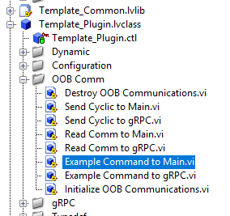

If the command enum is updated to support additional commands, the Read Comm to xx.vi must also be updated to support the new command enum. If the only changes are updating the Command Data and DVR clusters then these functions do not need to change.

